

Big Data Analytics and Visualization
LO1| LO2 | LO3| LO4
Section (1)
Final Assignment

Healthcare Insights Through Big Data: Analysis and Visualizations Project
Submitted to
WA`ED ALSAWAREAH
Submitted by
RAMA AL-MAJALI
22110119

June 18th, 2025
Spring 2024 – 2025

Contents
Task 1: Big Data Concepts & Data-Driven Decision-Making in Healthcare 3
1.1 Big Data in Healthcare: Advantages and Challenges 3
1.2 Impact of Advanced Data Analysis on Consulting Labs & Customer Experience 5
Task 2: Statistical & Graphical Techniques for Healthcare Data Analysis 6
2.1 Data Preparation and Manipulation 6
2.2 Statistical and Graphical Techniques 6
2.3 Scenario Insights and Interpretation 7
2.4 The Use of PySpark ML 11
Task 3: The Use of Data Manipulation – MapReduce Using Hadoop 12
Task 4: Professional Challenges for Data Specialists in Healthcare 17
4.1 Roles and Responsibilities of Data Specialists in Healthcare 17
4.2 Strategies for Ensuring Data Compliance 17
4.3 Ethical, Legal & Security Challenges 18
4.4 Real-World Impact on Consulting Labs 18
References 20

Task 1: Big Data Concepts & Data-Driven Decision-Making in Healthcare

Big Data in Healthcare: Advantages and Challenges
Big data has become a leading resource for insights in the healthcare industry. With it come many advantages that offer ways that help in the decision-making process in the industry. The fire advantage would we enhanced diagnostic and clinical insight. Healthcare datasets are rich with structured and unstructured data like EHRs, test results and device inputs, which offer deep statistical knowledge and pattern recognition capabilities. For example, in the case of Clinical Labs, trend analysis and bundling patterns helped identify frequently ordered tests and common test combinations which was important for optimising pre-packaged test panels.
Another advantage is that big data can give us insights on operational efficiency and resource planning. Big data analytics enables forecasting and predictive staffing to cut wait times, waste and costs on both the organization and patients. At Consulting Labs, they can investigate the monthly volume trend using regression models to forecast future demands and to support staffing and inventory decisions.
Public health monitoring and seasonality detection is another advantage that big data can give us insight into. Platforms that can analyse large amounts of data can inform early disease detection, time sensitive interventions and population wide trends. For example, conducting a seasonal volume analysis at Consulting Labs will reveal seasonal disease spikes like the flu that the lab must plan for.
Finally, big data can help in personalised patient care and service quality. Using predictive models and analytics pave the way for personalised interventions, having better diagnostic accuracy and outcomes. At consulting labs when analysing bundled tests for example like CBC, glucose, and creatinine, help makes deliver efficient testing that aligns with clinical trends.
Despite all of the advantages of big data in healthcare, challenges do arise. Data quality, variety and veracity are a common challenge because healthcare data is usually messy, inconsistent, and veracity sensitive which is why at Consulting Labs we have to make sure this issue is addressed by cleaning and null filtering the data at hand.
Data privacy, security, and compliance are also a common challenge when it comes to data, but it is especially important when it comes to healthcare data. Strict regulations like HIPAA and GDPR must be in place to limit how patient data is used and shared. Also, when it comes to the analysis of such sensitive data it has to be stored and encrypted safely, with secure access control and anonymity.
With big data also comes technical complexity and integration barriers. The adoption of big data technologies, including Apache Spark, Hadoop, and machine learning models, in healthcare facilities needs both technical knowledge and a smooth connection with the established clinical systems. Though at Consulting Labs we have managed to implement the forecasting and scheduling model, its implementation in a wider real-life setting would necessitate close coordination with IT systems, workflow redesign, and continuous maintenance processes, which shows how tricky the process of big data analysis can be.
Lastly, the explainability of analytical models is also another major obstacle to the implementation of big data solutions in healthcare. Clinicians must have confidence in, and comprehend the information presented by data tools, and models that are overly complicated or so-called black-box models may decrease trust in model outputs. Conversely, our work at Consulting Labs employed simple explainable techniques, including linear regression, trend-based visualization, and count aggregation, to, at the very least, guarantee that the answers are not simply accurate but can be easily communicated to non-technical stakeholders.

Impact of Advanced Data Analysis on Consulting Labs & Customer Experience
At Consulting Labs, there are many possibilities to enhance operations and patient outcomes and compete in a data-driven healthcare landscape by using advanced data analytics. Data use can offer enhanced critical areas of performance and experience.
Advanced data analysis can boost operational performance. For example, with test demand forecasting, Consulting Labs will be able to more effectively staff and manage reagent inventory as well as turnaround times. Pattern analysis of the seasons, i.e., knowing the winter peaks or the summer decline can enable the labs to staff in advance to meet the predictable volume fluctuations and putting less pressure on the available resources during peaks.
Improved patient satisfaction and speed is another impact of using advanced data analysis. For example, offering Pre-packaged test bundles of popular combinations of tests simplify the patient process. This, together with data-driven scheduling can minimise wait times, prevent backlogs and bettering the service quality, which will result in quicker result times and great patient satisfaction.
Consistent monitoring of test volumes and positive/negative result patters will give better internal quality control which is another important impact of advanced data analysis. This data can also be used to help identify abnormal changes in results early enough which could raise concerns on the health of the people. This eager analysis reinforces conformity and improves medical supervision.
Finally, with advanced analytics in place, Consulting Labs can offer targeted test panels, they can match offerings to patient and provider needs and can apply the insights to make business decisions. Trends of forecasting and bundling play an important role in establishing the lab as a progressive, data-based provider of services in a competitive healthcare environment and in an environment where patient health is at the forefront of the main objective of industry.

Task 2: Statistical & Graphical Techniques for Healthcare Data Analysis
In this exercise, a multi-source healthcare dataset comprising of diagnostic lab test records was loaded, merged, cleaned, and analysed using Apache Spark. Once the data had been cleaned and converted into a structured and unified form, various statistical and graphical models were used to discover patterns and trends useful to the operational and clinical planning of Consulting Labs. Four different scenarios, including test frequency, demand over time, seasonal change, and bundling patterns, were analysed and visualised with the help of Matplotlib and discussed in the context of data-driven decision-making.

Data Preparation and Manipulation
The data collected was made of 13 separate Excel files, with each one representing a different time range between January 2022 and April 2025. The files were merged using Apache Spark’s PySpark into a single data frame. Then I made sure the data was consistent across the datasets because they had different column structures, I did a schema alignment before merging. Once the files were combines and merged more transformations were done to clean and format the data.
I used the window functions in Spark to extract timestamps and forward-fill to match each test with the appropriate visit date. The records with null values or without test names or with invalid values were removed to enhance the quality of the data. The resulting cleaned data frame had standardised columns: the number of visits, the timestamp of the visit, the name of the test, and the test result. It was this cleaned-up form of the data that became the basis of all further analysis and visualisation.

Statistical and Graphical Techniques
I used Apache Spark’s aggregation functions and visualisation libraries such as Matplotlib and Seaborn to find patterns. Spark functions like groupBy(), withColumn(), count(), and orderBy() were applied to manipulate and summarise the data. For example, grouping test names and counting their occurrences revealed the most frequently requested diagnostics, while time-based grouping enabled demand trend analysis across months and seasons.

In terms of visualisation, Matplotlib was used to create professional, readable plots such as horizontal bar charts, line graphs, seasonal bar plots, pie charts, and filled area graphs. Seaborn provided enhanced colour palettes and formatting for grouped visualisations. These visuals allowed patterns to be easily interpreted, such as identifying winter demand spikes or commonly bundled tests. For forecasting future test volumes, a linear regression model was implemented using PySpark MLlib. This predictive model used month numbers as input features to estimate future test demand and was visualised alongside actual historical trends to aid resource planning.

Scenario Insights and Interpretation
I investigated four of the suggested scenarios, and they are as follows:
Most Requested Tests
I aggregated the frequency of test names and identified the top-requested diagnostics within the dataset. Then the most frequent tests were visualised in a bar chart to give a clear view of the core service demand at Consulting Labs. Using this insight, decisions related to inventory stocker, reagent purchasing, and staff specialisation are made. For example, from figure 1 we can say that Consulting Labs they need make sure that the Complete Blood Count test is always readily available since it is the most frequent test to decrease waiting times or unavailability.
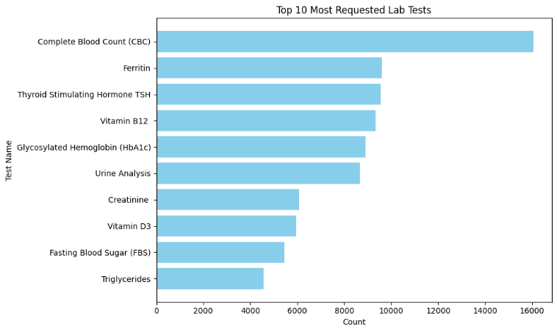
Figure 1: Most Requested Tests

Test Demand Trends Over Time
I grouped tests by monthly visit dates to observe demand across years. A line graph was used as a visual and it revealed seasonal peaks of request tests. Figure 2 shows a sharp rise in test requested in mid-2022 which was during the last peaks of covid, then test requests peeked at the highest around the middle of 2023 followed by a gradual decline until the 2025. The spikes and dips give insights on seasonal patterns. This trend analysis will help Consulting Labs to allocate staff properly and more effectively specially during high-demand periods to avoid understaffing.
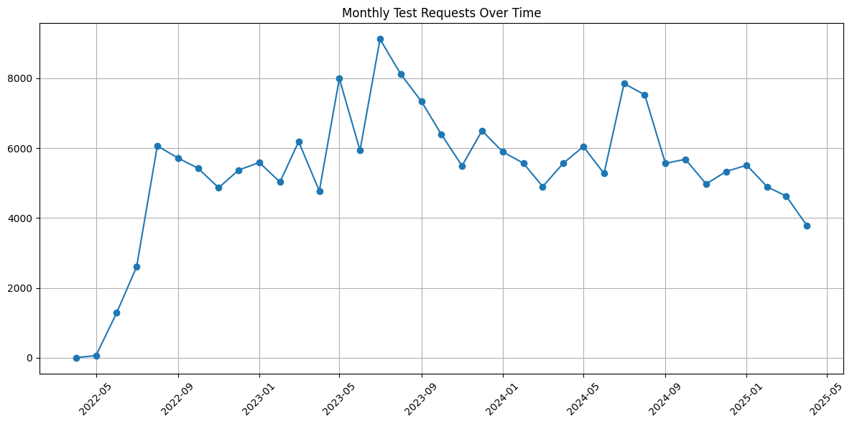
Figure 2: Monthly Requested Tests Overtime

Test Bundling Patterns
I used grouping and pair analysis we explore which tests are frequently ordered together. Figure 3 highlights the top 10 most frequently ordered test combinations. The most common bundle was CBC + Ferritin, followed by Free T4 + TSH. These combinations reflect typical diagnostic panels used for anaemia, thyroid function, and metabolic assessments. Consulting Labs can use the popular test pairings, to create fixed-price test panels that match patient needs while improving efficiency and satisfaction.
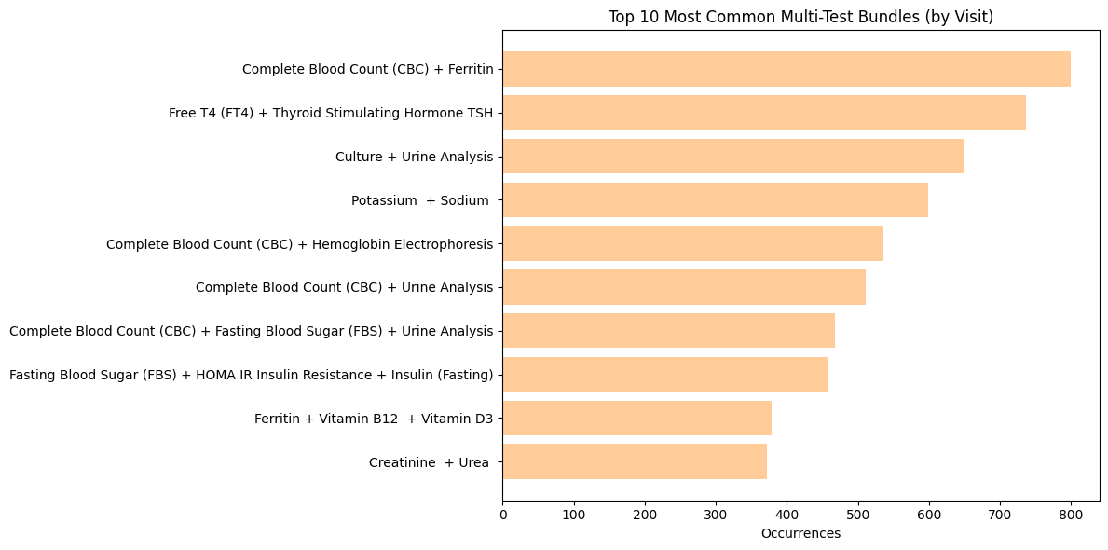
Figure 3: Test Bundling Patterns

Seasonal Variation in Test Types Requested
I mapped tests to seasons and discovered patterns in patient behaviour and public health concerns. Figure 4 highlights the top 5 most frequently requested tests in each season. The Complete Blood Count (CBC) test consistently ranks highest year-round, with slight peaks in autumn and summer. Other tests, such as Ferritin, TSH, and Vitamin B12, appear regularly across seasons, while HbA1c shows a relative increase in spring and winter. These seasonal patterns can help Consulting Labs align test availability with demand and tailor seasonal health campaigns.
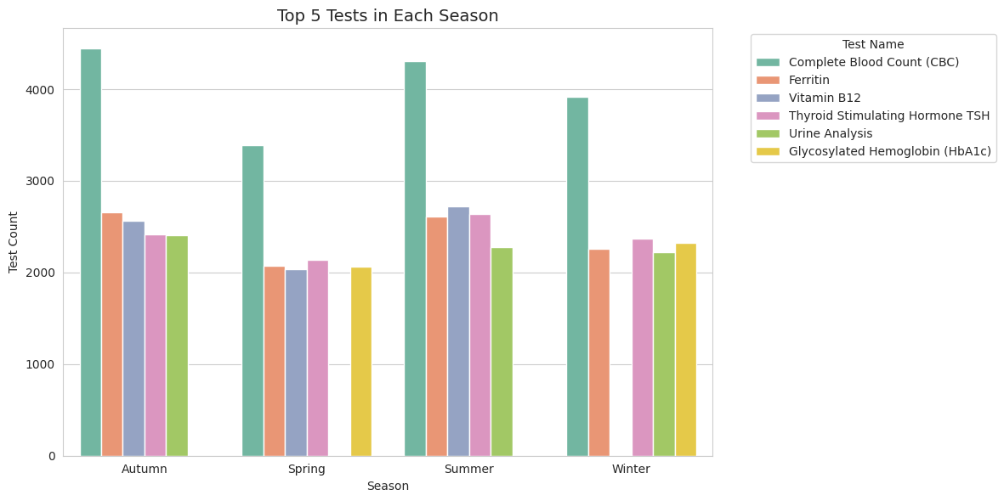
Figure 4: Seasonal Variation in Test Types Requested

The Use of PySpark ML
In order to generate projections on monthly test volumes, linear regression model was applied utilising the PySpark’s MLlib. Numeric features consisted of months, and the label was test volume. The model was based on historical data, and it was applied to predict values in future months. The trend forecast by experiencing a gradual change in the demand that is shown in the chart in figure 5 indicates that the demand is expected to recover after the demand decline experienced. Such predictive intelligence allows Consulting Labs to anticipate workload, adjust staffing levels, and plan inventory for reagents and consumables accordingly.
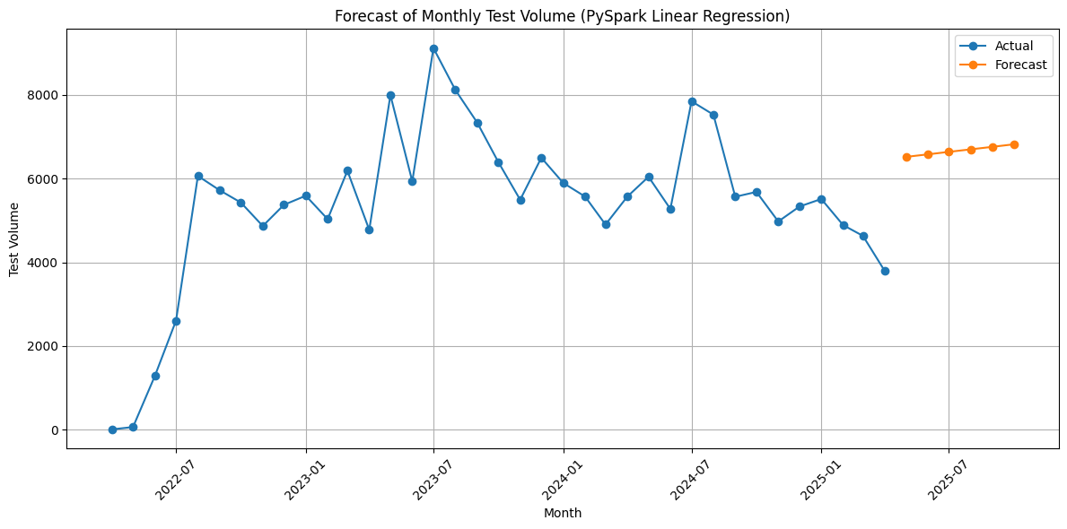
Figure 5: Forecast of Monthly Test Volume

Task 3: The Use of Data Manipulation – MapReduce Using Hadoop
In this task a MapReduce Job was done using Hadoop on Docker. The task done was Positive/Negative Count of the test results.
In the Mapper phase it reads each line of the input dataset then it tokenizes the line to identify keywords (e.g., “positive”, “negative”), then it emits a pair (label, 1) every time it finds a relevant keyword. In the Shuffle & Sort phase it groups together all (label, key) pairs by key—so all positive entries are grouped together, and all negative entries are grouped together. Finally, in the reducer phase, it iterates for each label and receives a list of 1s then it sums them up to get the total count for each sentiment.
I will be explaining exactly the steps done to run the MapReduce job.
The first step was to ensure that a local Docker Hadoop Cluster was setup.
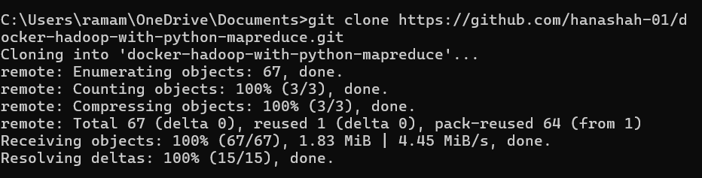
Cloning the repository:

Then I changed the directory to where docker composer is:

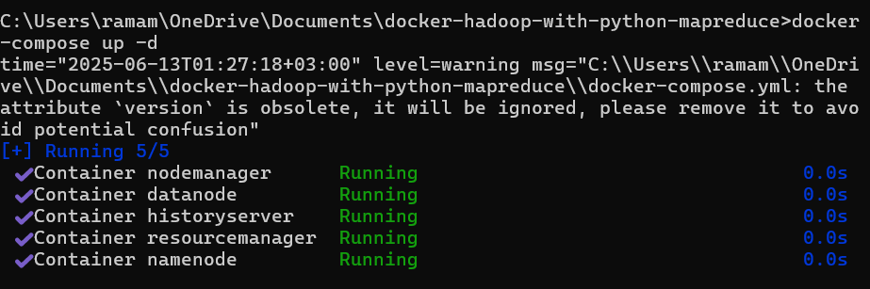
Now we can start the docker run:

Second, I did the steps to run a python MapReduce Function:
I first accessed the container of the Hadoop cluster’s namenode:
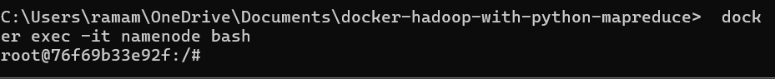

I then created a HDFS (Hadoop Distributed File System) folder structure to allocate the files:
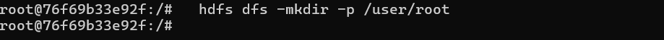
Then I exited the container and moved the input files from my computer to the namenode container:
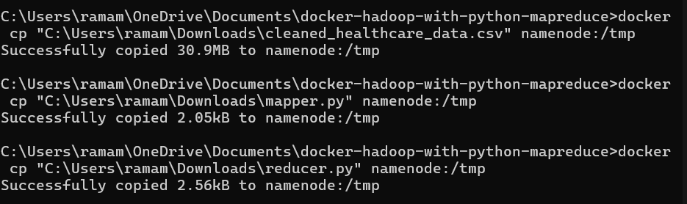

Then I went into the namenode container again to create an input folder:
After that I changed the directory to /tmp to move the input file into the input folder:
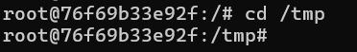
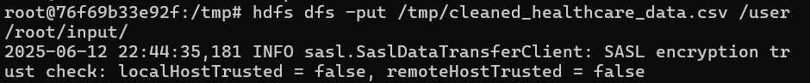
Then I found the path to the JAR file to locate the Hadoop string library JAR:
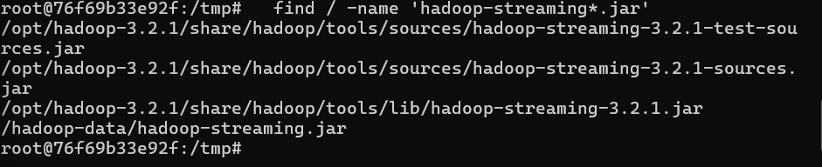
I then exported the JAR path and set an input and output path:
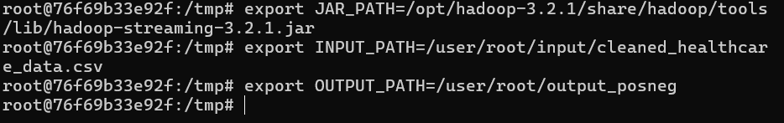
Then I set the mapper and reducer script paths:
Now we can run the Hadoop MapReduce job:
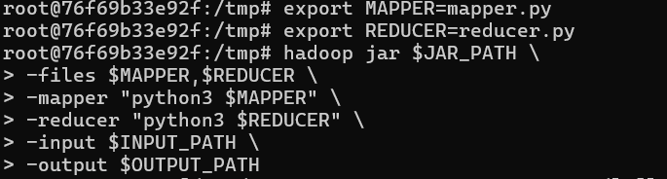
Then I located where the output files an ran it to get the output of the job:
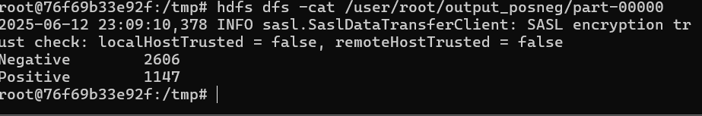
I copied the output file from HDFS to /tmp to export it later:
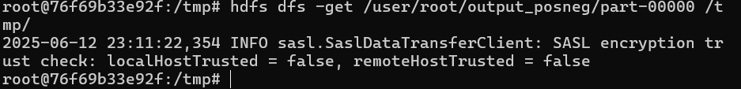
Finally, I exited the container and copied the file from the docker container to my computer:
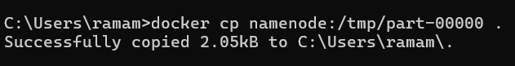

Evaluation of Data of The Data Manipulation and Preparation Methods and Tools
The results of the selected data preparation and manipulation techniques in Tasks 2 and 3 contributed largely to the knowledge that can be used to make operational and strategic decisions at Consulting Labs.
In task 2, Apache Spark was used to load and combine the Excel Files into one data set. This was critical towards consistent repetition of different file structure and processing high number of diagnosing records. The distributed computing model established by Spark enabled quick sets of groupings, filtering, and time-based transformations of the data set. Cleaning procedures like null value removal, timestamp adjustments as well as duplicates processing increased data quality and accuracy, which is essential to the healthcare setup where misleading trends might jeopardize clinical and operational data.
The selection of statistical techniques, including frequency analysis, trend plotting, test bundling identification, and linear regression forecasting were the ones that enabled us to reveal the formulas that were directly applicable in business planning. An example can be given where it is possible to determine the most popular ordered tests and the bundled combinations and help to make inventory and marketing choices. It was seen that the test type seasonal analysis identified trends in the scope of public health behaviour, which allowed their proactive seasonal staffing and resource-sharing. The proposed forecasting model, based on PySpark MLlib linear regression, gave Consulting Labs a perspective of the volumes of tests in the future, allowing it to anticipate short term changes in the demands.
Choosing the visualization tools, namely Matplotlib and Seaborn, helped a lot in converting raw data into visuals that could be easily understood. The visuals contributed to a more effective share of insights among stakeholders without technical education and allowed making data driven choices regarding service design, job assignment, and targeting promotions. Seasonal charts and forecast plots were laid out in colour codes labelled according to season so peaks and changes could easily be spotted and used to adjust campaign timing, or strategic hiring.
Task 3 brought an opportunity of utilising Hadoop MapReduce in order to discuss how a distributed batch processing could be applied to a healthcare-specific problem: the necessity to count the number of positive and negative test results. This activity was in the form of a simulation of real-life scenarios of batch processing systems in which summary statistics needed to be computed on a large dataset over to several nodes. The use of containerised Hadoop via Docker also denoted an expanding industry trend toward the application of scalable tools in virtualised setups. Although the results of the MapReduce were less sophisticated in their scope than that of Spark, they provided a key measurement, which could either be applied to performance monitoring or even reporting on patterns of patient health, or as an alert-generated dashboard.
Overall, the technologies used in both tasks are based on applied data engineering processes and industrial technologies. They enabled Consulting Labs to shift out of raw and unstructured data into strategic insights, with quantifiable business value. These can be better planning of resources, better packaging of test, better knowledge over operations and ability to forecast the demand in future based on past records. Consequently, all these approaches contribute to a more reactive, dynamic and data-savvy healthcare establishment.

Task 4: Professional Challenges for Data Specialists in Healthcare

Roles and Responsibilities of Data Specialists in Healthcare
The roles of data experts in the healthcare field are highly diversified because they all serve the purpose of making data reliable, secure, and actionable in treating and administrating the use of healthcare data. Such common examples are data analysts, data stewards, clinical informaticians, data engineers and compliance officers, who perform a different but related purpose within the health data ecosystem.
A healthcare data analyst extracts, cleans, combines and interprets a number of varying sources including lab results, electronic health records (EHRs) and patient feedback. Their knowledge is the source of decision-making based on the care of their patients, efficiency of their operations, the trend of testing psychologically, and even forecasting of the future. They should also develop dashboards, KPIs and graphical reports accessible to clinicians as well as to the executives.
Data stewards are the keepers of data. They impose data governance regulations, observe consistency among systems, work on metadata, and normalize terminologies. Through this they would help in bridging the gap between IT departments and healthcare professionals hence making the data meaningful, accurate, and trustworthy.
Clinical informaticians act as a bridge between the data science and clinical practice. They assist in the design data models that are compatible with medical workflow, certification that algorithms are clinically relevant, as well as aid development tools which facilitate the diagnosis, treatment, or monitoring of health. Their expertise also makes data solutions practice-oriented.
Data engineers are involved in the development and support of data pipelines to move information between systems to provide access and elastic processing in real-time. Engineers will be very instrumental in the integration of lab instrument test results data into analytical applications such as Apache Spark or Power BI in a place like Consulting Labs.
In the meantime, compliance and data privacy officers guarantee the conformity of all data processing to the national laws and ethics. They install role-based access controls, audit logging, data anonymization and take care of incident response plans in case of breach.
Moreover, data specialists are also starting to become in charge of model development and validation in the context of implementing the tools of machine learning, such as regression to predict test volumes or classification to define the risk groups. They have to make sure models are interpretable, fair and audited on a regular basis.
Together the roles of data specialists are more than just technical when they also entail governance, compliance, and collaboration roles as well as strategic alignment. The joint efforts of such organizations as Consulting Labs help to refine raw health data and contribute to its implementation into meaningful initiatives that will improve patient outcomes, enhance work in labs, and facilitate innovation.

Strategies for Ensuring Data Compliance
To maintain compliance with the law and security concerns, data specialists use a layered and proactive strategy. Their initiation begins with in-depth risk analysis that helps to draw the regulatory gaps and the loopholes in the existing systems. They develop controls to access sensitive patient information, such as role-based permissions, multi-factor authentication, as well as an encryption of data in transit and at rest. Moreover, a data governance policy is instated in organizations which establish information retention policies, consent practices, and criteria of anonymization of patient files. Initial and periodic refresher training of the staff is also an essential precept in the deterrence of error and maintenance of protocol. Lastly, information experts have well-crafted breach response and audit systems-drills, standardized records, and prompt incident response procedures-that can be used to find imminent breaches and deal with them expeditiously without missing out on records spilling or putting off regulators.

Ethical, Legal & Security Challenges
The use of healthcare data is a very delicate ethical and legal ground to tread on. In the US, specialists have to abide by the law of HIPAA that puts severe restrictions relating to the access, disclosure of PHI, and PHI retention, and in the EU, it is GDPR or the NIS2. They also have the ever-changing security threats, such as the ransomware attacks, as it was witnessed with the large healthcare systems breaches. Quite a range of ethical concerns of secondary data use appears as well when data is used in secondary purposes, e.g. commercial research or analytics without proper patient consent and transparency. Security Where data security is concerned, they need to be able to guarantee data integrity: to ensure that it does not become corrupt, such as in the creation of medical and laboratory records, and/or to sanitize (or de-identify) shared data sets, particularly those used in reporting or research.

Real-World Impact on Consulting Labs
Data specialists are the core of the digital transformation in a data-driven healthcare setting, Consulting Labs are liable to various challenges that affect the process of daily activity and long-term planning rather severely. Unless acted upon these issues can cause patient service delivery bottlenecks, slow down revelations, and cause compliance and the decrease of public trust.
Among the most important challenges is maintaining quality of data and its consistency. Specialists receive thousands of tests records every day that are in multiple systems and formats, so they should clean, transform, and validate datasets before they can be analysed. The data quality is not up to the expected standard; often with multiple duplicates, inconsistent field formatting, or complete fields missing, which may skew tests demand projections or obscure valuable trends in patient health indicators. To give an example, when flawed data gets through a test bundling investigation, it might result in improperly bundled diagnostics, destroying not only operational performance but also clinical accuracy.
Data security and compliance is another problem. The healthcare information is quite sensitive and governed by regulations like HIPAA, or even local data protection regulations. To guarantee the safety of personal data, data specialists make sure every stage in the data pipeline is encrypted, anonymized and properly accessed. Failure in the safety of patient test results or client registered data may lead to legal fees, tarnishing of reputation and loss of stakeholders. Consulting Lab, consequently, should set costs on secure data lakes, strong access control as well as routine audits, which are under the domain of the data team.
The ethical issues also take precedence. The experts need to be careful in the construction and implementation of the models, as they should not contribute bias or even represent untrue health status. As an example, in case of using the regression models to trace the moved trends of the health signs over timeline, once misinterpreted or over-fitted, the data can result into wrong alarms or misdirected suggestions. These situations have relevance to explainability, model validation, and clinical cooperation in a data-driven environment.
Last but not least, communication barriers tend to exist between technical experts and decision-makers. Although it is possible to generate the right predictions and visualizations, the inactionable ideas may limit their effectiveness in business regardless of their effectiveness. Analysts need to consequently develop analytical and storytelling abilities, so that outcomes of instruments, such as Spark and Power BI, can turn into more understandable policy of labs, distribution of resources, or advertisement.
In conclusion, even though data specialists enable Consulting Labs to leverage big data in the provision of patient-centred care and strategic planning, they should operate continuously in the environment of challenges in data integrity, compliance, ethics, and communication. The impact of the ability to control those issues has direct impact on the power of the organization to work effectively, serve its customers in a transparent manner, and be able to innovate within competitive healthcare market.

References
- Ankit Sujantee (2022). The Future of Healthcare is Data-Driven. [online] Apexon.com. Available at: https://www.apexon.com/blog/the-future-of-healthcare-is-data-driven/.
- Batko, K. and Ślęzak, A. (2022). The Use of Big Data Analytics in Healthcare. Journal of Big Data, [online] 9(3). doi: https://doi.org/10.1186/s40537-021-00553-4.
- Chiruvella, V. and Guddati, A.K. (2021). Ethical Issues in Patient Data Ownership. Interactive Journal of Medical Research, [online] 10(2), pp.1–9. doi: https://doi.org/10.2196/22269.
- Indeed (2025). What Is a Healthcare Data Analyst? With Skills and Requirements. [online] Indeed Career Guide. Available at: https://ca.indeed.com/career-advice/finding-a-job/health-care-data-analyst.
- Kalath, R. (2025). A Complete Guide to Healthcare Security & Compliance in the Cloud. [online] ClearDATA. Available at: https://www.cleardata.com/blog/guide-to-healthcare-compliance-in-the-cloud.
- kapfer, daniel (2025). Data-Driven Decisions for Improved Patient Outcomes - Admedica. [online] Admedica. Available at: https://admedica.com/2025/04/10/data-driven-decisions-for-improved-patient-outcomes/
- McCormack, M. and McCormack, M. (2023). Healthcare Data Compliance: Security, Privacy & Compliance. [online] Compliancy Group. Available at: https://compliancy-group.com/healthcare-data-compliance.
- Miller, J. (2024). Ethical Considerations in Healthcare Data Analytics. [online] Comchart.com. Available at: https://www.comchart.com/ethical-considerations-in-healthcare-data-analytics.
- Nazar Kvartalnyi (2024). Data Security in Healthcare: Strategies & Practices. [online] Inoxoft . Available at: https://inoxoft.com/blog/data-security-in-healthcare-strategies-and-best-practices.
- Rivera, V. (2024). The Critical Role of Data Security & Compliance in Healthcare. [online] Insight. Available at: https://www.insight.com/en_US/content-and-resources/2024/the-critical-role-of-data-security-and-compliance-in-healthcare.html.
- Sagar, S. (2025). Healthcare Risk and Compliance: 5 Key Challenges to Address in 2025. [online] Metricstream. Available at: https://www.metricstream.com/blog/healthcare-risk-compliance-key-challenges.html.
- Sifferlin, A. (2018). Is Big Data Finally Changing Health Care? [online] TIME. Available at: https://time.com/5208266/is-big-data-finally-changing-health-care.
- Staff, K. (2023). Top 5 Benefits of Big Data Analytics in Healthcare. [online] KMS Healthcare. Available at: https://kms-healthcare.com/blog/5-benefits-of-big-data-analytics-in-healthcare.
- Staff, O. (2025). Data Privacy in Healthcare: Compliance and Security | Osano. [online] Osano.com. Available at: https://www.osano.com/articles/data-privacy-in-healthcare.
- Stiglic, G., Kocbek, P., Fijacko, N., Zitnik, M., Verbert, K. and Cilar, L. (2020). Interpretability of machine learning‐based prediction models in healthcare. WIREs Data Mining and Knowledge Discovery, 10(5). doi: https://doi.org/10.1002/widm.1379.
- Sushant Gangurde (2023). Importance of Lab Data Analytics in Healthcare: Testing to Reporting. [online] CrelioHealth For Diagnostics. Available at: https://blog.creliohealth.com/the-importance-of-lab-data-analytics-in-healthcare-from-testing-to-reporting.
- Team, K. (2025). Big Data in Healthcare: Opportunities and Challenges. [online] Keragon.com. Available at: https://www.keragon.com/blog/big-data-in-healthcare.
- Tential (2024). Big Data in Healthcare: Leveraging Data for Better Patient Care & Research | Tential. [online] Tential.com. Available at: https://tential.com/insights/the-role-of-big-data-in-healthcare-leveraging-data-for-better-patient-care-and-research.
- Williams, B. (2024). What Is a Healthcare Compliance Analyst? [online] MedTrainer. Available at: https://medtrainer.com/blog/healthcare-compliance-analyst.
- Worsham, C.M. and Jena, A.B. (2025). Big Data Can Make America Healthier. Here’s How to Do It Right. [online] TIME. Available at: https://time.com/7291563/big-data-healthcare-maha-christopher-worsham-anupam-jena-essay/.
- Zarour, M., Alenezi, M., Ansari, M.T.J., Pandey, A.K., Ahmad, M., Agrawal, A., Kumar, R. and Khan, R.A. (2021). Ensuring data integrity of healthcare information in the era of digital health. Healthcare Technology Letters, [online] 8(3), pp.66–77. doi: https://doi.org/10.1049/htl2.12008.

